Linear Regression
Linear regression is a statistical model used to predict the relationship between independent and dependent variable .The value of an independent variable does not change based on the effects of other variables. It is denoted by x
. The value of the dependent variable change when there is a change in the value of the independent variable and is denoted by y. The algorithm is used to predict the value of an output variable based on the value of an input variable
Application of Linear regression
It is applied in calculating economic growth(to calculate gross domestic productGDP).
Used to predict what the price of a product will be in the future (price will go up or down).
used to estimate the number of houses a builder will sell in the coming months and at what price
It is used to predict the number of runs scored by the player in upcoming games based on previous performance
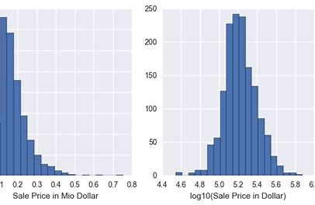
Logical Regression
It is a supervised learning classification algorithm is used to predict the value of a target variable .In logistic regression used to compute the probability which lies between the interval 1 and 0.The graph is a curved line instead of the straight line. The outcome must be a discrete value (either Yes or No,0 or 1 ,true or false. It is used for solving the classification problems.
The logical regression is used to predict if the incoming mail in the inbox is spam or not spam or to predict if the online card transaction is fraudulent or not or if a marketing company to predict the a group of user will buy a certain product or not.

Decision tree
It is a predictive modelling tool that can be used in many areas. Decision tree can split the dataset in different ways based on different condition using powerful supervised algorithm. They can be used for both classification and regression task. It has two main types of decision trees that are based on the target variable (categorical variable and continuous variable decision tree)
A decision tree is a tree like graph with
Nodes- representing the place where we pick an attribute (ask a question)
Edge- represent the answer to the question
leaves – represent actual output or class label
Decision trees can represent any Boolean function of the input attributes(Boolean gates AND,OR)
used to represent binary tree for predicting whether the person is fit or unhealthy provided giving various information such as age, lifestyle, eating habits etc
Decision tree helps in assessing prospective growth opportunities for business based on historical data
Decision tree helps in simplify a marketing budget and make informed decisions on the target market that the business is focused on
SVM (Support Vector Machine): It is a supervised machine learning algorithm capable of performing classification regression and even for detection. The linear SVM works by drawing a straight line between two classes. They are unique because SVM can define bot linear and non-linear boundaries
In SVM algorithm they find the points closest to the line from both the classes. Which are called support vectors. Then compute the distance between the line and the support vectors. This distance is called margin
SVM algorithm are used when a number of features are high compared to a number of data points in the dataset. The objective of SVM is to find the best line in two dimensions or the best hyperplane in more than two dimension(The maximin distance between data points of both classes
They are used in real life supplication like Image segmentation,Image classification(distinguish between healthy and diseased leaves
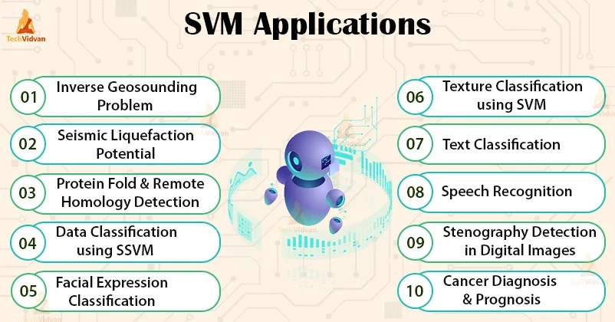

Naiv Bayes: It is a classification-based algorithm based on Bayes theorem. It is suitable for binary and multiclass classification
KNN (K- Nearest Neighbours): It is a simple ,supervised machine learning algorithm that can be used to solve both classification and regression problems . KNN predict the correct class for the test data by calculating the distance between the test data and all the training points.
It is called a lazy algorithm because it doesn’t perform any training when you supply the training data. Instead, it just stores the data during the training time and doesn’t perform any calculations.it doesn’t build a model until a query is performed on the dataset so it is used in data mining.
In KNN algorithm the following procedure is used
1 Load the data and Choose K value
2 Find the distance to all training data samples
3 Store the distance on an ordered list and sort it
4 Choose the top K entries from the sorted list
5 Label the test point based on the majority of classes present in the selected points.
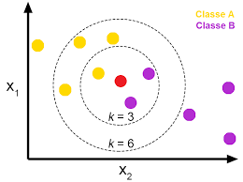

K -Means Clustering is a type of unsupervised learning which is used when you have unlabelled data. The goal of this algorithm is to find groups in the data with the number of groups represented by the variable K.
K -means clustering uses centroids, it randomly initiated points in the dataset and assigns every data point to the nearest centroid. After every point has been assigned ,the centroid is moved to the average of all the points assigned to it.The process repeats and every point is assigned to its nearest centroid ,and are moved to the average of points assigned to it .The algorithm is done when no point changes in the assigned centroid.
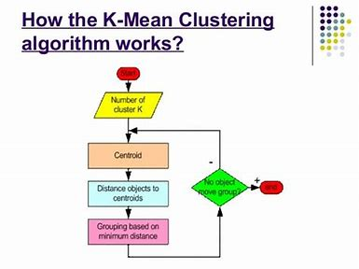
Random Forest

Random forest is a powerful and versatile supervised machine learning algorithm that grows and multiple decision trees to create a forest. It can be used for classification and regression problem

